**Mayor Lloyd Winnecke**

**City of Evansville**

**Citizen’s Budget**

**2020 Summary Budget**



**Historical Notes**

* Founded by Hugh McGary, Jr. in 1812, the City of Evansville was later (1814) named for Colonel Robert M. Evans.
* In 1847, with a population of 4,000, Evansville was chartered as a city.
* Railroads reached Evansville in 1853.
* In 1900, Evansville became Indiana’s third largest city, at a population of 59,000.
* Victory Theater, the City’s first air-conditioned venue, opened in 1921.
* 1942-1945 the City converted its industrial manufacturing facilities into an industry for the production of WWII wartime products, such as the P47D Thunderbolt aircraft and LSTs (Landing Ship Tanks).
* The Lloyd Expressway (State Road 66) was constructed in 1987.
* 1995 - Indiana’s first riverboat casino opened in Evansville, Casino Aztar.
* In 2011, the City of Evansville constructed Ford Center Arena downtown.
* 2017-2018 brought new development to Evansville with the opening of the Doubletree Hilton Hotel and the Stone Family Center for Health Sciences downtown.

**Who We Serve**

* 117,963 Residents (21.5% under 18 years, and 15.5% over 65 years)
* 51,580 Households
* 9,082 Businesses
* 44.15 Square Miles

**The Budget Process**

* Department staff prepare draft budgets beginning in May for the upcoming fiscal year.
* Meetings between departments and the administration occur to review budget requests/needs.
* Budget requests are subjected to internal review and modification and the Administration’s budget is compiled for Common Council review.
* Public budget hearings occur throughout August and September in Common Council sessions. At this time, citizens may provide the Administration and Common Council with their comments concerning the budget.
* By state law, the Common Council must pass the budget by November 1st each year.
* Subsequent to Common Council action, the Indiana Department of Local Government Finance (DLGF) will review/modify the budget and issue a formal budget approval order in January.

**2020 Budget Summary**

**2020**

**2019**

Revenue

215,876,855

184,704,601

Expense

212,546,470

181,635,263

**Utility**

**2020**

**2019**

Revenue

92,341,814

87,496,005

Expense

92,160,629

87,298,976

**General Fund**

**2020**

**2019**

Revenue

439,441,105

402,801,240

Expense

432,891,426

395,155,441

**Combined Total Budget**

**The City of Evansville – Citizen’s Budget 2020**

**Budget Revenues**

The City receives revenue to fund operations from several sources. Some of those major sources are shown in the chart below.

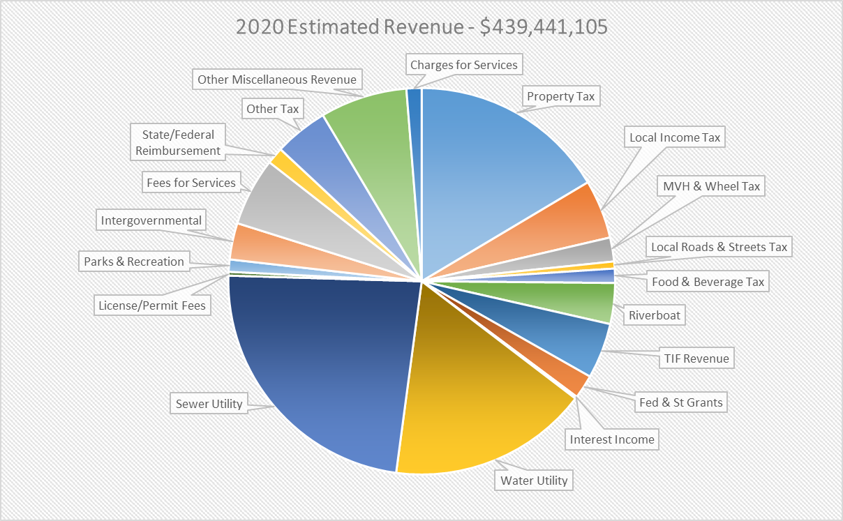

Property Tax: $ 60,416,788

Local Income Tax: $ 18,067,268

MVH & Wheel Tax: $ 7,360,000

Riverboat Funding: $ 13,633,467

TIF Revenues: $ 17,077,228

Park & Recreation: $ 3,790,505

Water Operating: $ 61,495,602

Sewer Operating: $ 85,778,726

The City’s largest revenue source is property tax. Property tax revenues have increased only slightly in recent years, while property tax caps have continued to grow substantially. This results in relatively flat property tax revenue growth since 2012.

**Over the past 10 years, the City has received approximately**

**$100 million less in property tax revenue due to property tax caps.**

**Budget Expenses**

In order to meet the needs of the citizens of Evansville, the City provides various services including public safety, street maintenance, parks and recreation, economic development, blight elimination, code enforcement, water and wastewater utilities, and many other services. The expenses related to providing these services are paid by the City using the revenue streams mentioned above. Below are some of the City’s major expenses categorized by expense type.

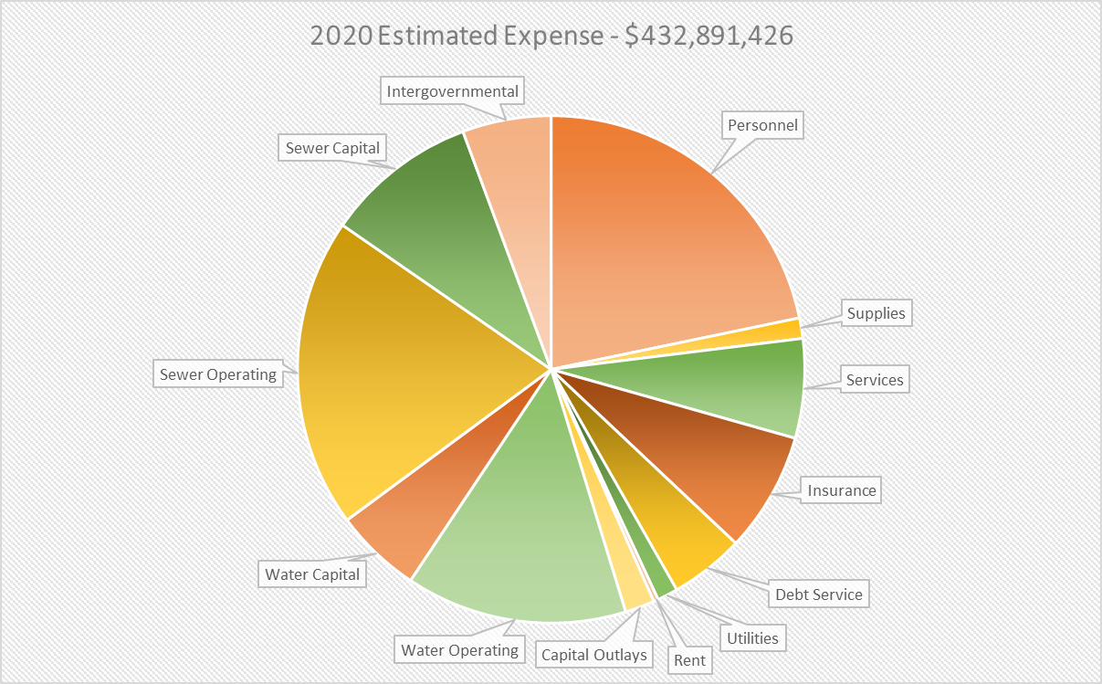

Personnel: $ 94,129,157

Insurance: $ 33,073,979

Services: $ 27,395,179

Utilities: $ 5,706,434

Water Operating: $ 61,061,105

Sewer Operating: $ 85,502,650

**The City of Evansville – Citizen’s Budget 2020**

**2020 Key Capital Projects**

* Purchase a $1.2 million aerial ladder fire truck
* Continue design and construction of the new Mesker Park Zoo penguin exhibit
* $1.2 million Walnut Street project (Regional Cities)
* $1.5 million road resurfacing City-wide
* New Deaconess Aquatic Center construction
* Continued funding of blighted property program
* $500,000 contribution to the Affordable Housing Trust Fund
* Purchase of police equipment (Cars, Body Cameras, Taser & Safety Vest Refresh, Bomb Robot) $1,032,000

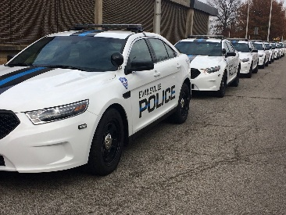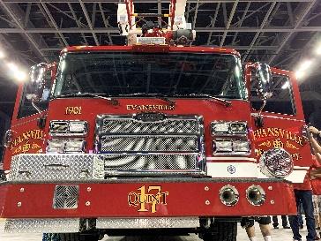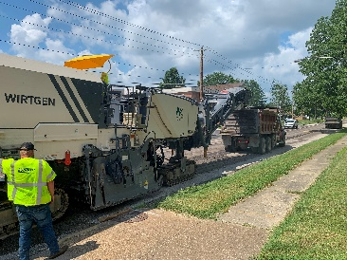

**Cost Drivers**

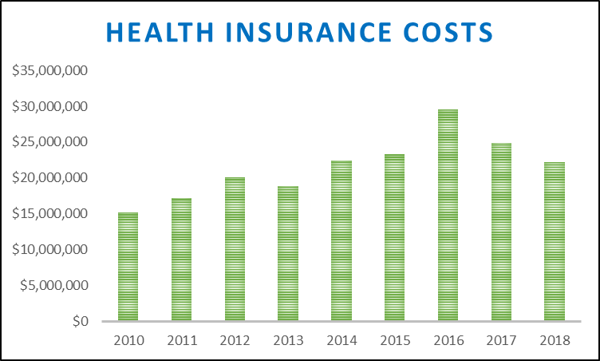

The City health insurance plan is self-funded.

Medical insurance costs vary greatly from year

to year. The unstable nature of insurance claims

can make this particular cost difficult to budget.

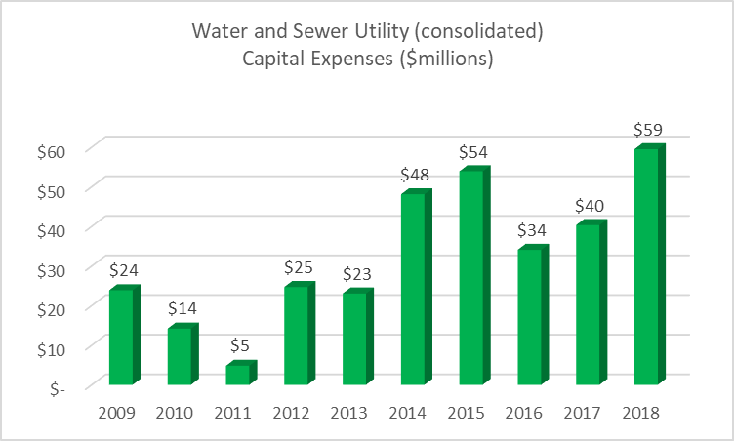

The Evansville Water & Sewer Utility has, over

the last 10 years, increased capital project spending from $24 million in 2009 to $59 million in 2019. Projects funded include major infrastructure improvements such as the Effluent Pump Station and Water Main Replacements.

**The City of Evansville – Citizen’s Budget 2020**

**Moving Forward**

A look at the City’s recent accomplishments, as well as, our future attractions.

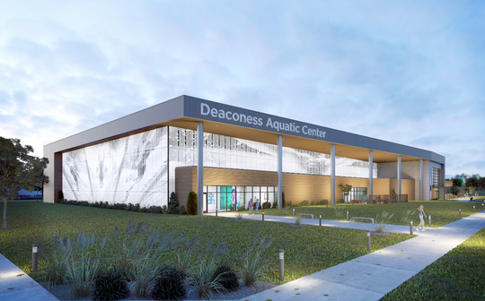

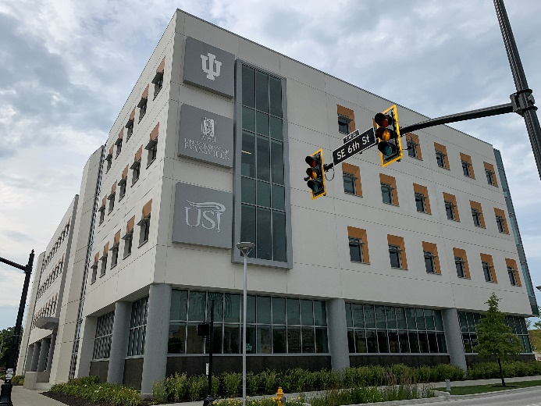

Deaconess Aquatic Center Stone Family Center for Health Sciences

(Projected Completion 2021) (Completed 2018)

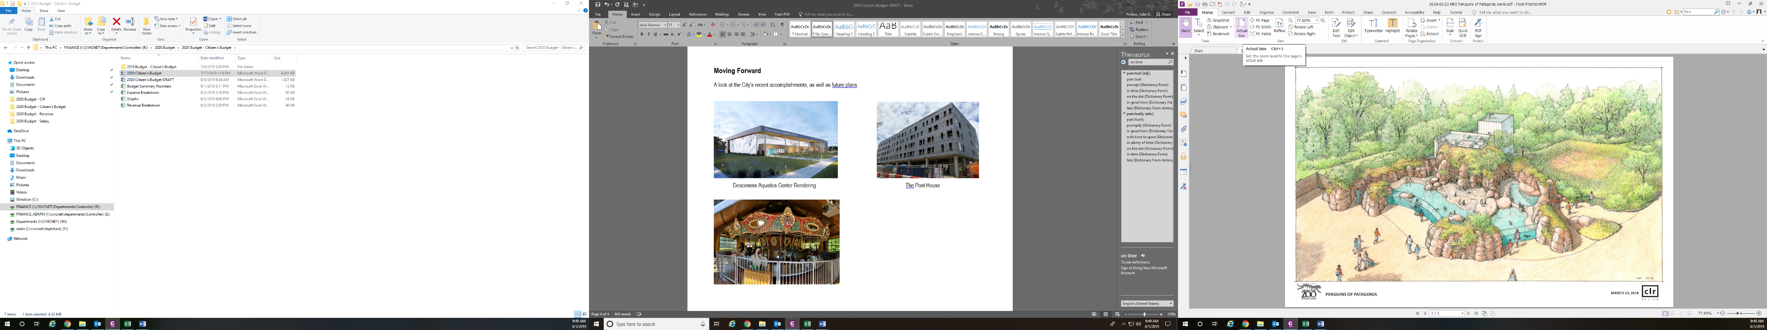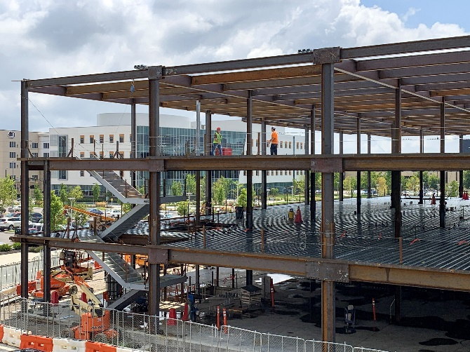

Deaconess Clinic & Research Center Mesker Park Zoo Penguins of Patagonia

(Projected Completion 2020) (Projected Completion 2021)

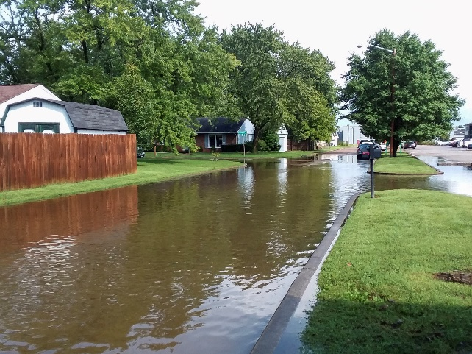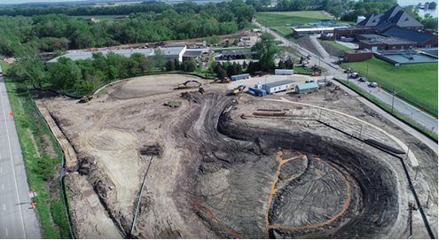

EWSU

Sunrise Pumping Station (IOCP Requirement) Iroquois Drive Drainage Improvements

(Projected Completion 2020) (Projected Completion 2020)